Performance Measurement Lab
Student ID _____________________
Student Name _____________________
Start Time ________________________
Finish Time ________________________

Practice 1. The kernel timer interval

For this part of the exercise, run the timestamp program with 4 threads (the -p 4 command-line option) executing. Save the output to a file named output.out. Then, open this data file with the graph program and answer the following questions. You may have to run the timestamp program many times, with different options for the threshold and number of iterations to get data that clearly depicts the timer interval. If your machine is faster than 700Mhz, you may need to increase the number of iterations and/or decrease the threshold. For the record, the command line used on my 700Mhz machine to generate the data that the graph program screen shots display was as follows:

Timestamp -t 1000 -i 1000000 -p 4 > output.out

(copy your screen shot of your output.out figure here)
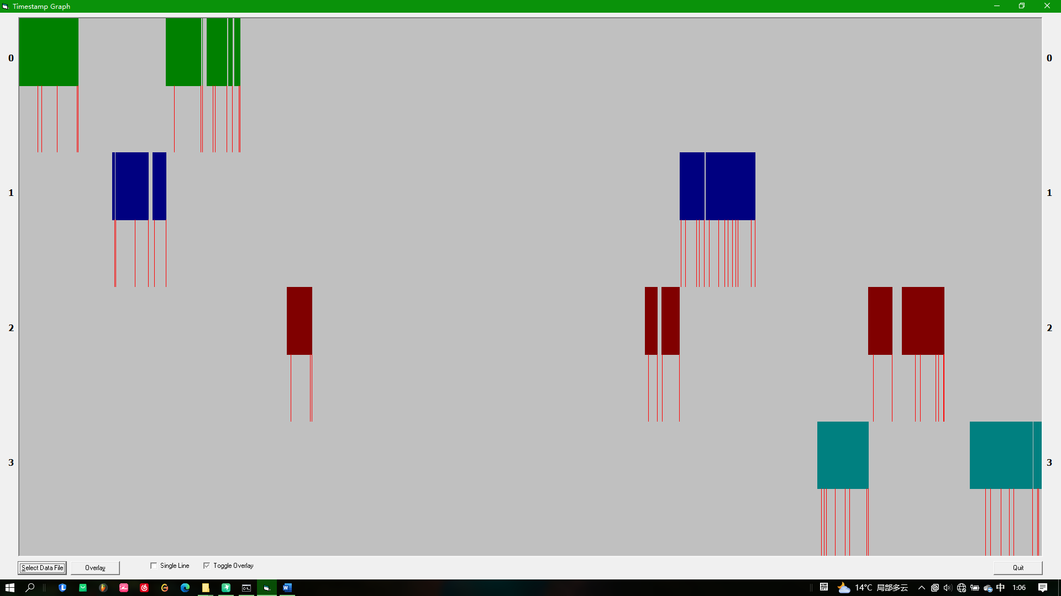
Answer the following questions:
- Using the timestamp program, what is the estimated clock rate of your processor in cycles per second? (2 points)
- What is the approximate timer interval of your operating system? Report your answer in both cycles and in seconds. (14 points)
- What are the minimum and maximum lengths of the timer interrupts that you observed? Do not count timer interrupts that switched to a different thread or different process. (2 points)

Max：7867710
Min：612

- How many total interrupts did you record? (2 points)

65

- How many of these were timer interrupts? (2 points)
- How many timer interrupts resulted in context switches to another thread that belongs to the timestamp program? (3 points)

7

- Did a timer interrupt resulted in a context switch to a different process? If so, how many times did this occur, and how many timer intervals did these other processes run? (3 points)
- Did a thread finish executing before the end of a timer interval? If so, how many times did this happen and what did the operating system schedule for the rest of that timer interval? Was it one of the other timestamp threads, or another process? (3 points)
- How many timer intervals elapse from the time your program started to the time your program ended? (1 point)

鼠标悬停在红线上可以看到持续时间，求和即为答案

- How many of those intervals did your program not run? (1 point)

5

- Expressed as a hyphen delimited string of the label numbers, what was the execution order of the threads? (For example, from the data in the screen shots above, the execution order was 0-1-2-3-0-1-2-3-0-1-2-3-0-1-3) (2 points)

0-1-0-2-1-3-2-3

Practice 2. VC Profiling
Write down the answers with screen shot.s
2.1
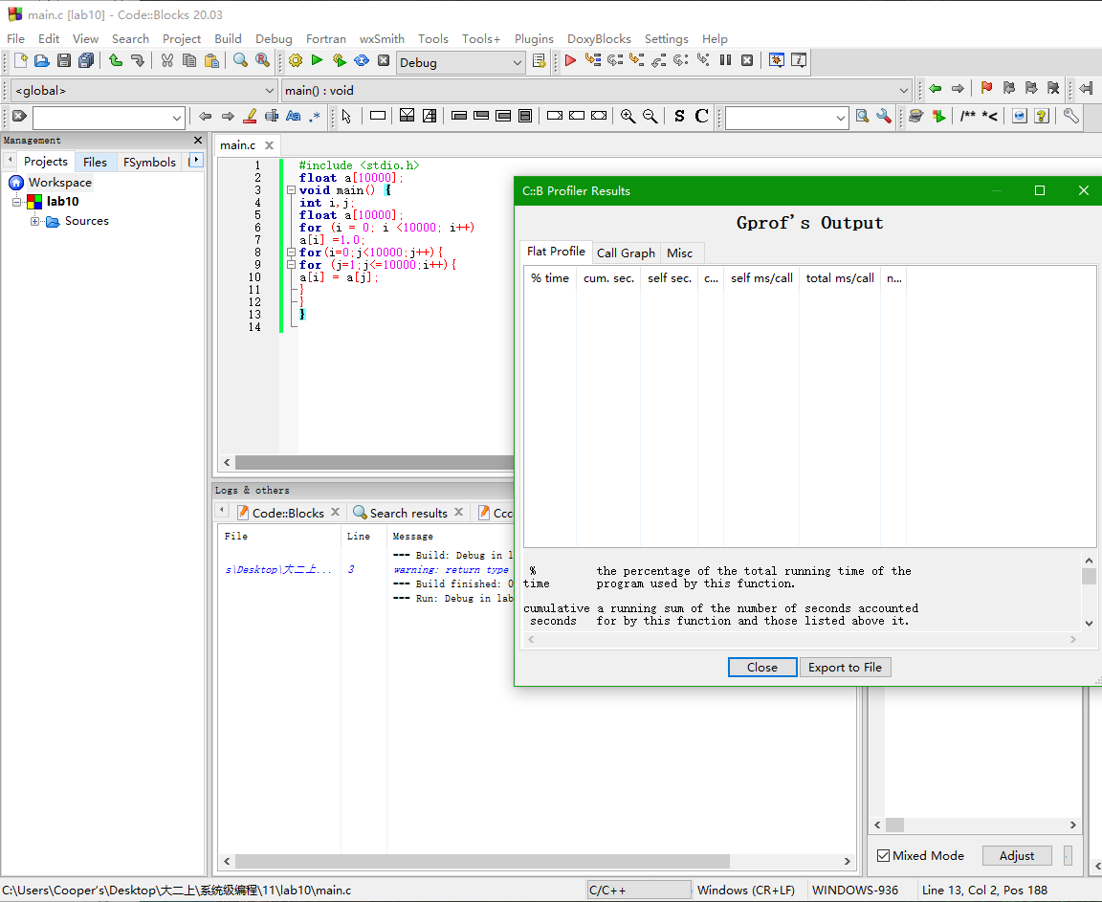

2.2
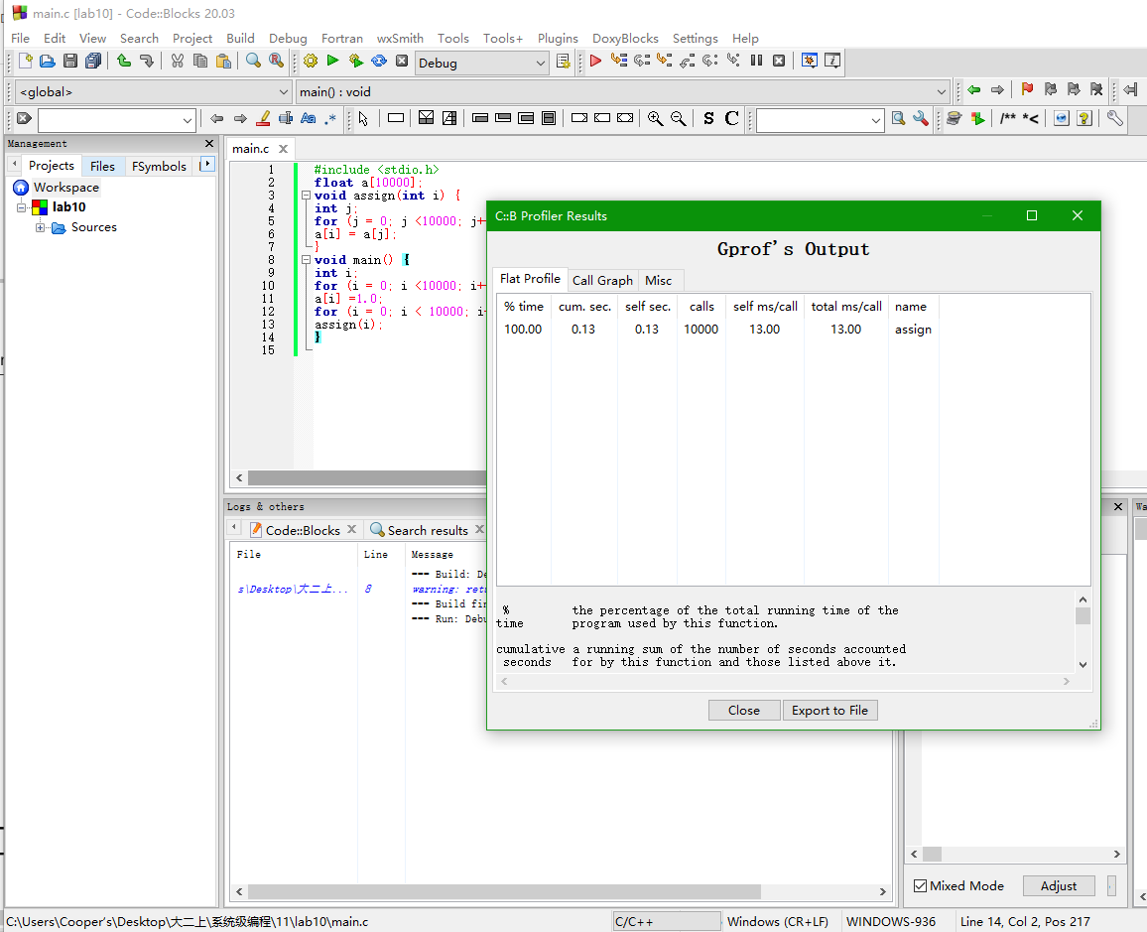
- 在第二个循环里，assign（）被调用10000次
- 两个
- 100%
- a running sum of the number of seconds accounted for by this function and those listed above it.

2.3
0.09
0.10
0.09
0.11
0.02
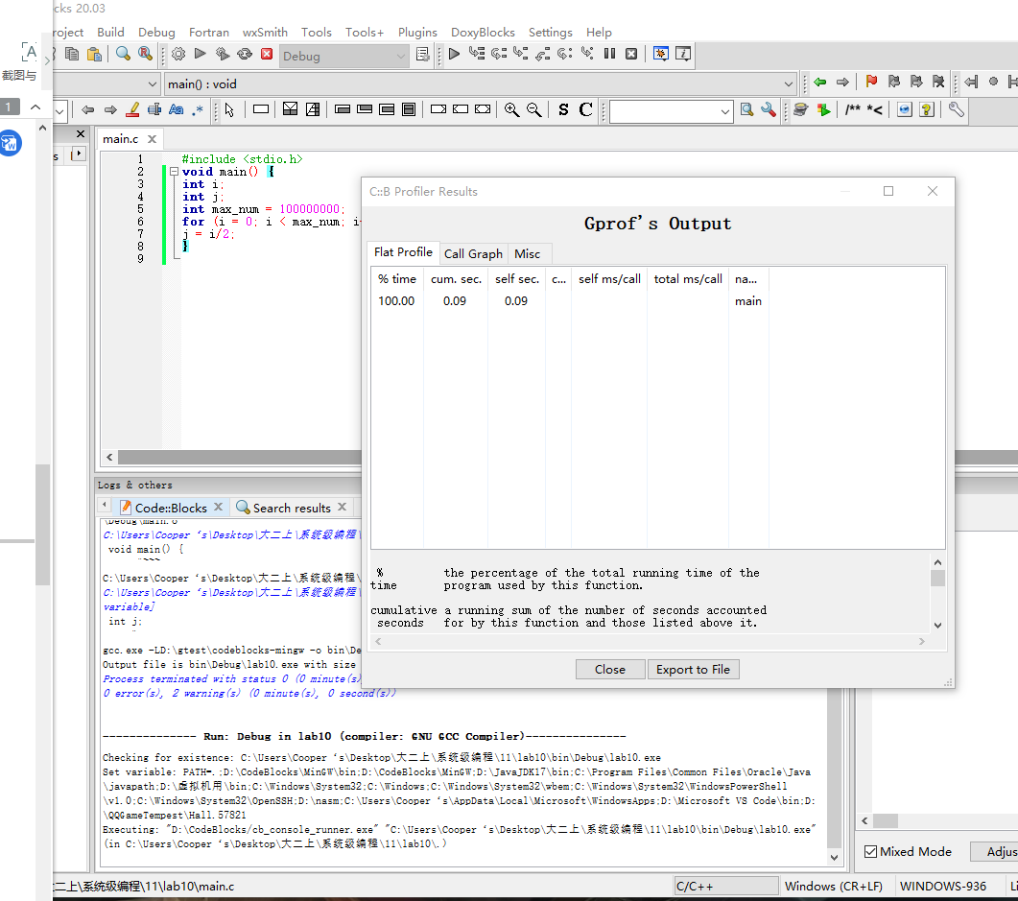
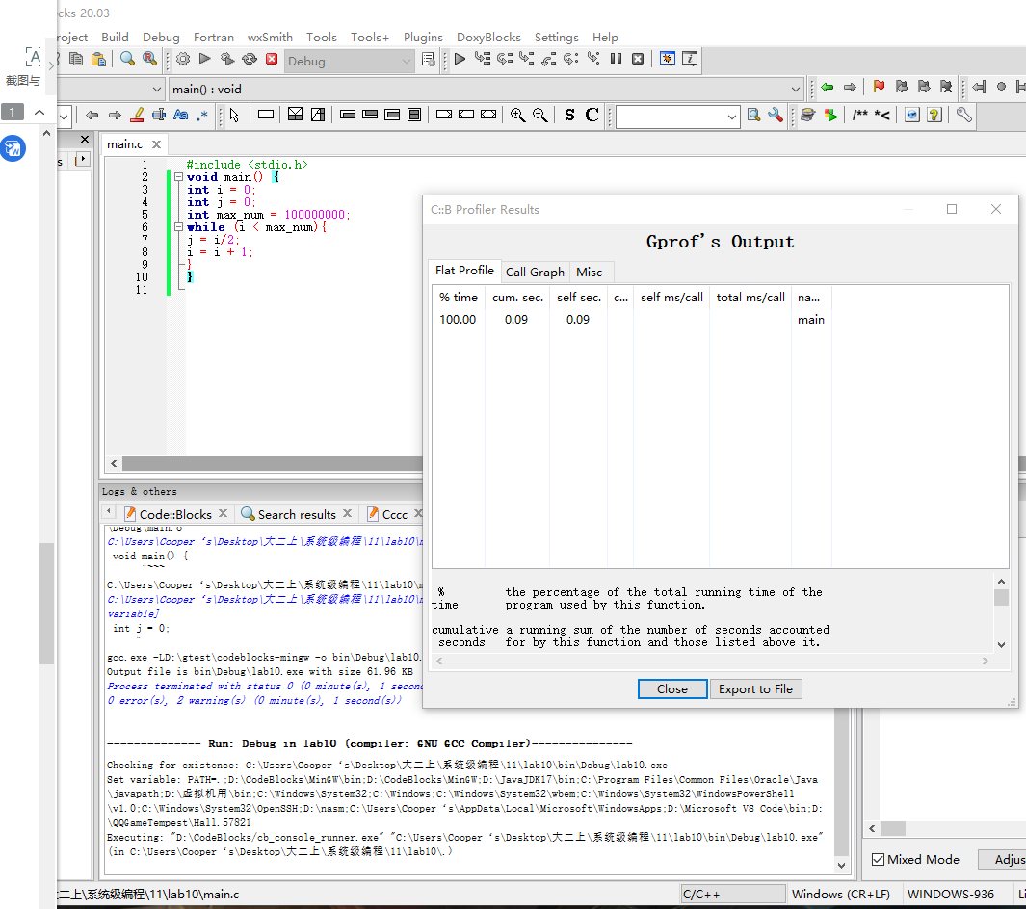
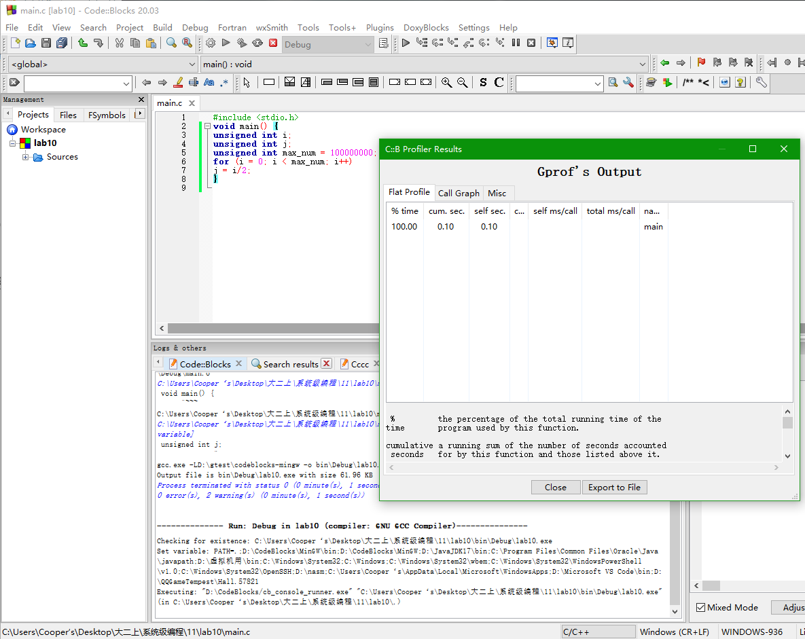
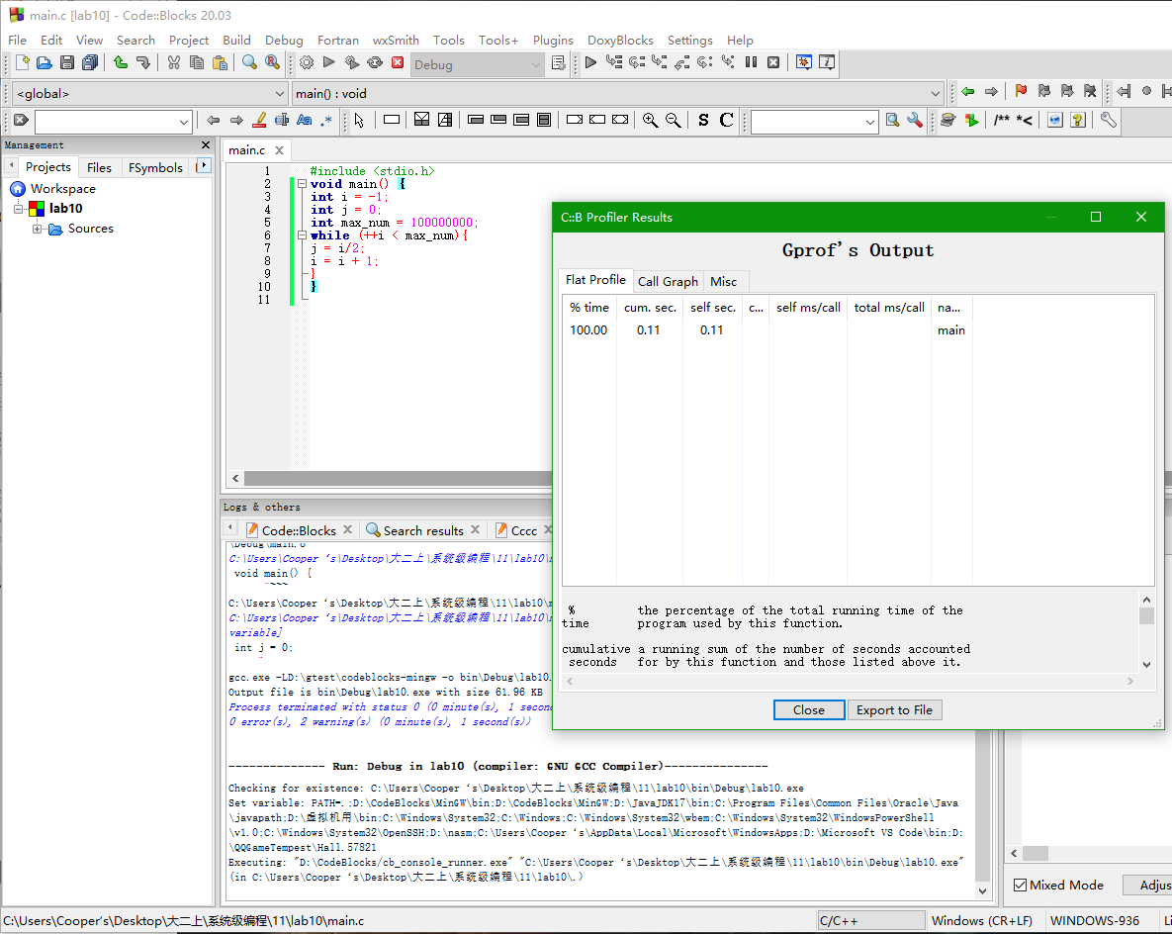
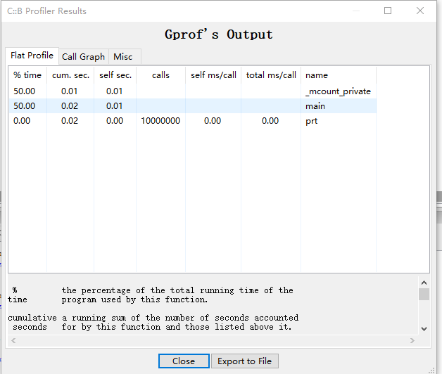
3.1
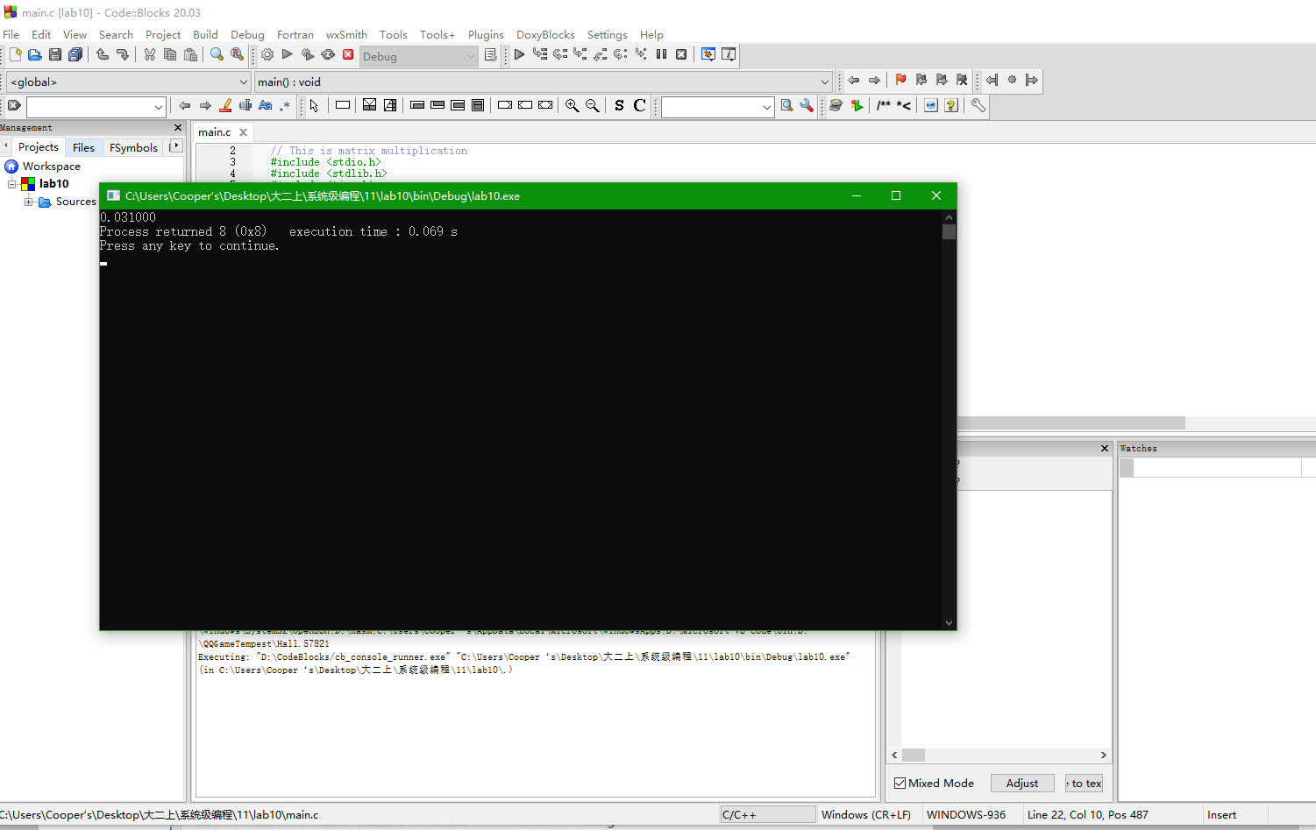

3.2
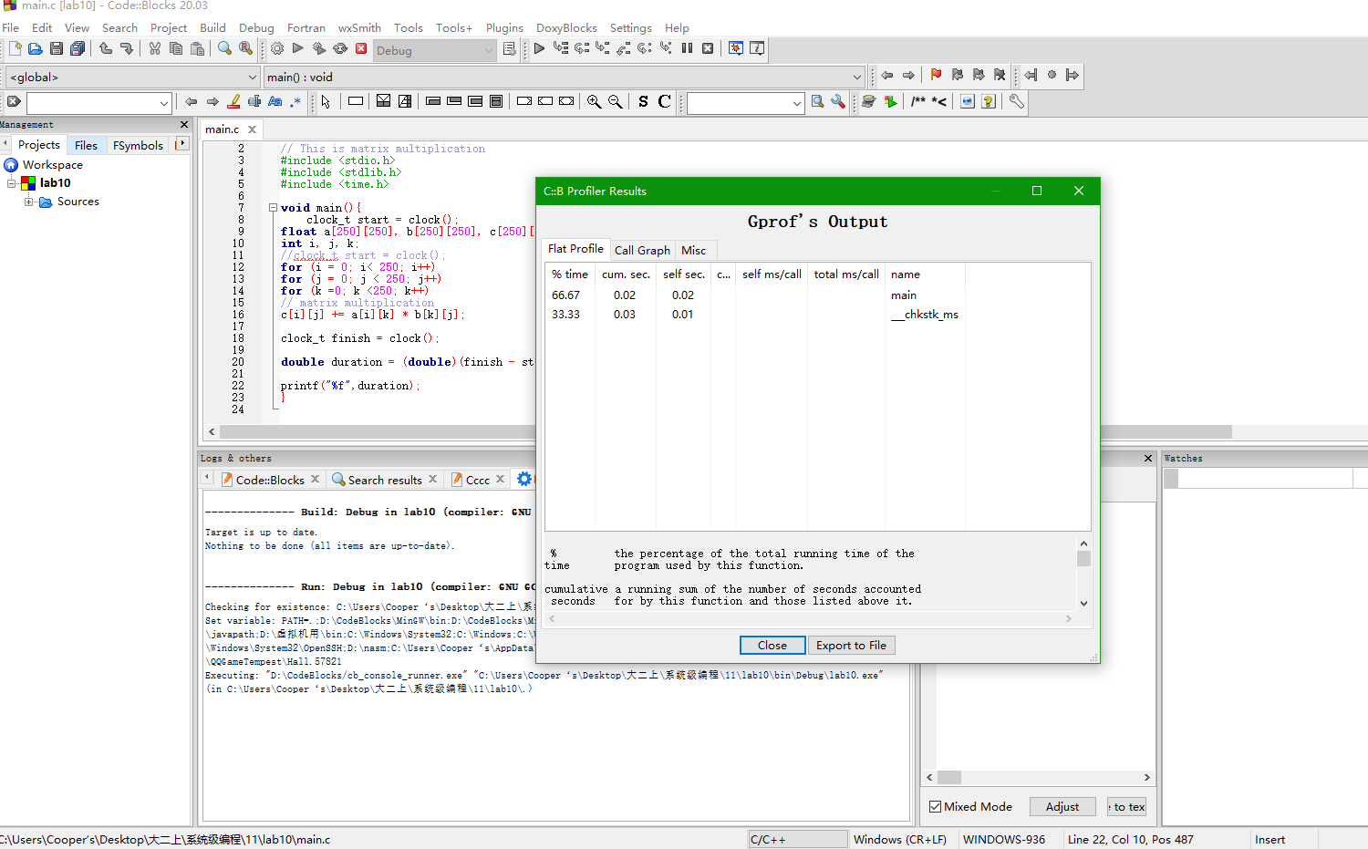

//这次课没听，借鉴同学的😇

